Adroddiad Blynyddol
Cyngor Cymuned Llanwenog Community Council
Annual Report
Ebrill 2024- Mawrth 2025

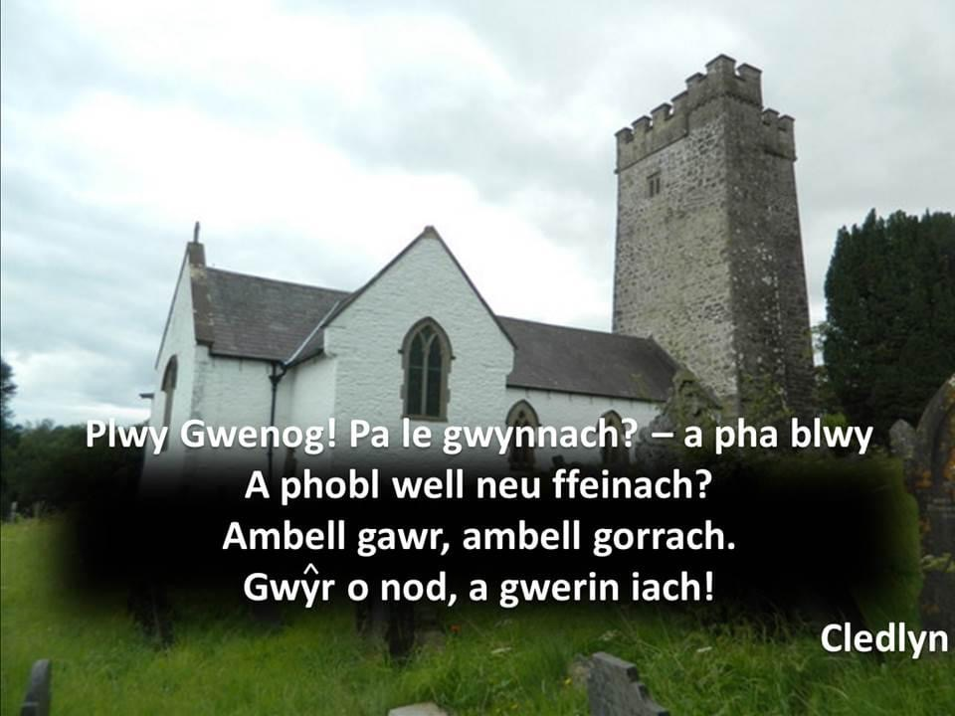

1.0 Introduction

1.1 Llanwenog Community Council consist of 11 Parish Councillors, who do not represent any political party and who are elected every 4 years. A Clerk/Financial Officer is employed to handle all arrangements for meetings and preparing an agenda to deal with the records and financial and administrative matters linked to implementing the Council’s work.
1.2 The County Councillor, Cllr Euros Davies also attends the meetings but does not have a vote, he is a member of the Independent Political Party.
1.3 The Chairman for the last year 2024-2025 was Cllr Alwena Williams and the vice Chair was Cllr Bryan Thomas.
1.4 There is a representation from the 8 villages within the community which are Rhuddlan, Cwmsychpant, Cwrtnewydd, Llanwenog, Drefach, Gorsgoch, Brynteg and Alltyblaca.

2.0 Aims and Objectives

2.1 The Council’s key aims are:
- To act as a link between public sector organisations and the community on a range of subjects including the environment, planning, community facilities, community safety and other issues affecting the area
- To develop a picture of community needs in order to influence services and policies
- To represent the views of the community
- Provide a wide range of advice, information and support for the community and local voluntary groups
- Identify concerns and issues and seek to develop solutions with other partner organisations
- Support community projects, organisations and groups

3.0 The Council’s Activities

3.1 Llanwenog Community Council are an active part of the community and work hard to improve the facilities on offer and the appearance of the Parish, as well as the well being of our residents. The following were undertaken in 2024/2025 to aid our aims and objectives.

- Assessed and responded to all Planning Applications and also reported unauthorised developments to the Local Planning Authority’s enforcement team.
- Responded to a request for a ‘Village in Bloom’ competition and have bought two concrete water troughs to be used as planters, one in Brynteg and the other in Llanwenog. The support of Ty Cwm Nursery’s have been sought to buy the flowers. Two of the troughs were planted with flowers.
- The Remembrance Sunday was organised and held in person by the Community Council with over a 100 people present.
- Continued holding Hybrid meetings with some members present in the Hall and some on Zoom.
- Bought a new Defibrillator and Stand for Alltyblaca from the Walk for Life proceeds. A further walk is proposed on the 27th April 2025.
- Salt Bins were passed to be bought for the Aber road, following requests from the local community.
- The Kiosks were repainted. Drefach Kiosk was moved.
- The War Memorial was cleaned by the Councillors.
- Monitoring and Maintenance of the defibrillators were transferred over to the Community Council.
- Councillors represented the Community Council at One Voice Wales Meetings
- Councillors represented the Community Council in a meeting with the County Council Officials.
- Organisation of the VE Day celebrations
- Worked more closely with the Police and PC Liz Jenkins has attended several meetings during the year.
- Undertook a survey of the views of people regarding the 20mph in Drefach and sent this to Elin Jones AM and Ben Lake MP.
- Ideas came for next Christmas and to plant / put Xmas trees in each village and possibly do some carol signing.

4.0 Issues impacting the local community

- Flooding in Highmead Terrace
- Traffic Speed in Drefach and Alltyblacca
- Discussions of the impact of the 20mph on the Parish
- Cutting of overhanging trees and hedgerows
- Filling of potholes
- Need for Salt Bins
- Clearing of overflowing drains
- Planning and unauthorised development
- Financial support to charities which benefit the residents of the Parish
- Provide support to the organisations within the Parish and collaborate with them on occasions
- Request for mobile library and post office
- Organising of events such as Remembrance Sunday and Annual Sponsored Walk
- Community Boundary Review
- Councillors attended the Code of Conduct training held by the County Council

5.0 Governance and accountability

• Administered its own affairs effectively, as evidenced by both internal and external audits, ensured good governance and held regular monthly meetings. The Community Council filled two vacancies during the year.
- Kept the residents of the Parish informed through the Community Council’s website and facebook pages.
• The Community Council’s main funding in 2024/25 was the Precept of £15,000.00 and the Council recorded an income of £19045.87 and an expenditure of £14160.02 taking over £4885.85 to the next financial year of 2025/26. The precept has remained at £13,000 for 2025/2026 following a review of the budget.
• All Community Councillors declined to take the payment of £154.00 each for their duties.

Remembrance Sunday

