Cyngor Cymuned Llanwenog
Biodiversity Report and Plan
Llanwenog Community Council
April 2025

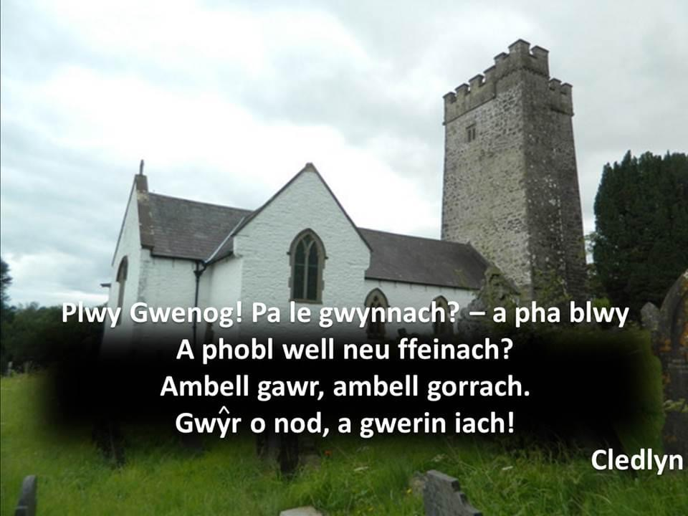

1.0 Introduction

1.1 Under section 6 of the Environment Wales Act, Llanwenog Community Council has a requirement to maintain and enhance biodiversity in the exercise of functions in relation to Wales, and in so doing promote the resilience of ecosystems, so far as consistent with the proper exercise of those functions.
1.2 Our duty to maintain and enhance biodiversity follows the Nature recovery Action Plan for Wales (NRAP) guidance, by producing a plan that supports the guidance given within the NRAP plan. The key elements of the plan include;
- Embed diversity into delivery, and raise awareness of its importance
- Safeguard special sites and species
- Restore and create habitats
- Tackle key pressures, such as pollution and invasive non-native species
- Use and collect biodiversity evidence

1.3 The Council has met its duty to PLAN – by meeting and agreeing on a proposed plan to deliver the actions within the plan.

2.0 Intended actions and past examples of actions taken

1. All planning applications submitted to Llanwenog Community Council for review will continue to be scrutinised with due consideration for any adverse impact on the environment. Consistent with objections and observations made over a number of years, the Council will take particular care to ensure that any developmental impact on surface drainage, sewerage, flooding, amenity impact, tree cover and impact on existing resources such as educational provision is duly notified to the Planning Department at Ceredigion County Council.
2. Llanwenog Community Council will continue to work with, Ceredigion County Council, Natural Resources Wales, Keep Wales Tidy and Rachel Carter – Local Places for Nature Officer to promote and secure the preservation of our two parks, SSSI’s, footpaths, ‘Help yourself’ wild fruit garden etc. within its boundaries as places where awareness of the importance of biodiversity can be communicated, and where natural resources can be enjoyed without adverse impact to ecosystems. The Council will continue to use its website to provide any information resource relating to these natural assets, and also to provide historical and contemporary information relating to the Parish.
3. Llanwenog Community Council will also monitor, maintain and protect such footpaths and rights of way as are recognised and established within its area of jurisdiction, and ensure that they continue to provide access and amenity to residents and visitors alike.
4. Llanwenog Community Council will continue to engage with the staff and pupils of Ysgol Dyffryn Cledlyn along with Llanwenog Young Farmers Club and other societies in order to promote awareness of biodiversity and ecology as part of the wider educational experience. The Council annual has takes part in the Keep Wales Tidy Local Places for Nature scheme and the Community also undertake a Butterfly Watch in Cwrtnewydd. Ysgol Dyffryn Cledlyn actively encourage pupils to grow their own food and do this in the school also. In July 2022 Llanwenog Community Council donated 3 fruit trees to the school.
5. Llanwenog Community Council will continue to consider the environmental impact of its procurement decisions, and will give due priority to environmental concerns alongside price and other determining factors along with supporting the local economy and businesses within the Parish wherever possible.
6. Llanwenog Community Council will continue to seek to control the spread of invasive botanical species through engagement with appropriate experts. Eradication and intervention will be undertaken on the basis of best available environmental advice and current practice. The clearance of the river Cledlyn in Cwrtnewydd was done under due restriction by a qualified company.
7. Llanwenog Community Council will continue to liaise and work with Cynghrair Llanwenog on the great work they are doing promoting and preserving the history of our natural environment and history.

