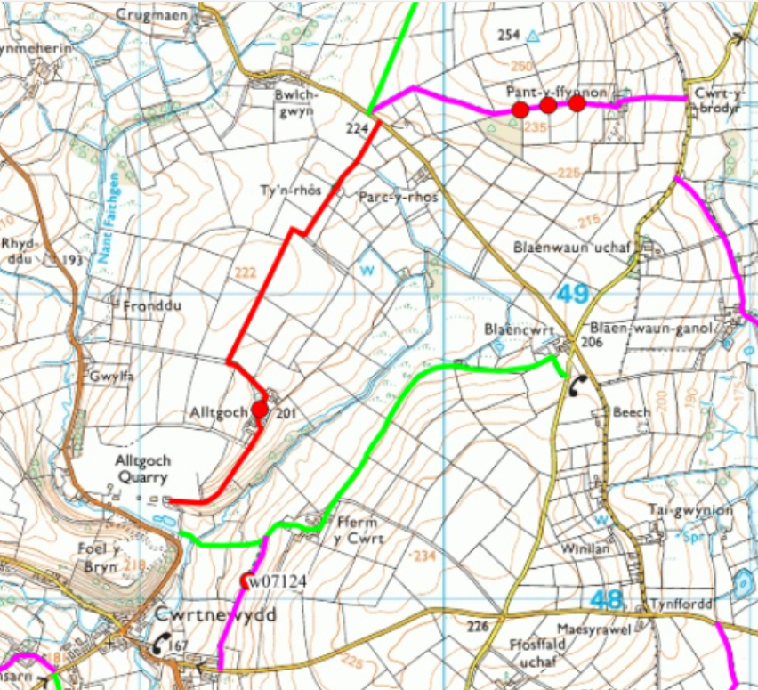
Yr Hen Ysgol: Mae’r ysgol wreiddiol gyferbyn â Chapel Seion bellach wedi’i throsi’n chwaethus yn deras o gartrefi. The original school opposite Seion Chapel has now been turned into a terrace of dwellings.
Taith Gerdded 2025 Sponsored Walk
Capel Seion Chapel: Codwyd yn 1820. Built in 1820.
Margaret Evans: Ganwyd hi yng Nghwrtnewydd ym 1800; priododd â Benjamin Frances, gof ym 1828, cafodd wyth o blant, collodd 4 yn eu babandod: profodd tlodi difrifol y 1840au yn ormod, fe droesant at y ffydd Formonaidd gyda'r addewid o fywyd gwell yn America. Bu farw gŵr Margaret a thri o'i phlant o golera wrth hwylio i fyny'r Mississippi ond parhaodd i fynd ymlaen; gan gyrraedd Salt Lake City ym 1852. Priododd ei merch a oedd yn weddill a chafodd 13 o blant, ond bu farw'n ifanc, gan adael Margaret i'w magu, bu farw ym 1880. She was born in Cwrtnewydd in 1800; married Benjamin Frances, a blacksmith in 1828, she had eight children, lost 4 in infancy: the abject poverty of the 1840’s proved too much, they converted to the Mormon faith with the promise of a better life in America. Margaret's husband and three of her children died of cholera whilst sailing up the Mississippi but she kept going on; arriving in Salt Lake City in 1852. Her remaining daughter married and had 13 children, but died young, leaving Margaret to bring them up.
Coed y Foel: Enw’r Goedwig i’r chwith wrth deithio allan o Gwrtnewydd, a saif Foel y Bryn 700m uwch lefel y mor ar y top – bu twr o gerrig gwynion yno. The forest to the left as you depart Cwrtnewydd, and Foel y Bryn sits at 700m above sea level at the top – there was once a tour of white stones there.
Fferm Bryn-yr-Eglwys Farm: Safle encilfa mynachod a adeiladwyd gan Abaty Tally ym 1170 fel estyniad o'u Maenor Fynachlogaidd yn Rhuddlan Teifi. Site of a monk’s retreat built by Talley Abbey in 1170 as an extension of their Monastic Grange at Rhuddlan Teifi.
Gwynfil Cottage: Fu hwn ym mherchnogaeth y Cware, ond bellach mae wedi cael ei brynu ac wedi cael ei droi nôl yn dy. Mae’n debyg mae ei enw ar fap 1890 oedd Rocken Hall. This was in the ownership of the Quarry, but was bought and has been turned back into a house. It’s called Rocken Hall on the 1890 map.
Y Felin: Melin flawd i wneud bara a bwyd i’r anifeiliaid. Rhys Davies oedd melinydd olaf Cwrtnewydd, trodd rhod ei felin am y tro olaf yn 1969. Daeth Lloyd yma wedyn ai ddenfyddio i storio a sychu grawn. Gwerthwyd nifer o nwyddau yma hefyd. A flour mill to make bread and food for the animals. Rhys Davies was the last miller at Cwrtnewydd, he turned his mill for the last time in 1969. Lloyd then came here to store and dry grain. A number of goods were also sold here.
Cae Cerrig – Roedd yna dy yn y cae i’r dde wedi croesi’r bont o’r enw Cae Cerrig. There was a house in the field to the right after crossing the bridge known as Cae Cerrig.
Fron Goch a Cofadail – Adfail dau dy a saif wrth fynedfa’r Cware. Mae’r cware yn cael ei redeg gan GD Harries & Sons. Mae Cware Alltgoch a Bryn bron gyferbyn a’i gilydd, ac yn darparu craig tebyg. Remains of two houses which stand at the entrance to the Quarry. The Quarry is run by GD Harries & Sons. Alltgoch and Bryn Quarry are opposite each other and expose similar kinds of sedimentary rocks and structures.
Alltgoch - Man geni Abel Morgan ym 1673. Ganwyd Morgan ap Rhydderch ym 1625 yn Alltgoch, Cwrtnewydd; tirfeddianwyr cyfoethog; trodd at y ffydd Fedyddiwr a daeth yn weinidog Bedyddiwr, cafodd ei erlid ar hyd ei oes. Roedd ei frawd hŷn Rhys yn swyddog ym Myddin Model Newydd Cromwell ac ymladdodd mewn llawer o'r brwydrau pendant yn Ne Cymru. Daeth Morgan yn weinidog Bedyddwyr ym 1697 ym Mlaenau Gwent; fodd bynnag, ym 1711 penderfynodd ddilyn ffrindiau a theulu a oedd eisoes wedi ymfudo i America ddiwedd y 1600au; oherwydd erledigaeth gartref. Adfywiodd ei egni a'i frwdfrydedd at ffydd y Bedyddwyr ledled nifer o gapeli Pennsylvania. Fe'i cofir fel yr 'Abel Morgan Digymar'. Dilynodd Rhys, aelodau'r teulu i Pennsylvania lle bu'n byw tan 102 oed; ysgrifennodd Benjamin Franklin ei ysgrif goffa. Mae Alltgoch bellach yn gartref i Huw, sy'n enwog am ei braidd o Ddefaid Llanwenog. Birthplace of Abel Morgan in 1673. Morgan ap Rhydderch born in 1625 in Alltgoch, Cwrtnewydd; affluent landowners; converted to the Baptist faith & became a Baptist minister persecuted all his life His older brother Rhys was an officer in Cromwell’s New Model Army and fought in many of the decisive battles in South Wales. Morgan became a Baptist minister in 1697 in Blaenau Gwent; however, in 1711 he decided to follow friends and family who’d already emigrated to America in the late 1600’s; due to persecution at home. His drive and enthusiasm revitalised the Baptist faith throughout the many chapels across Pennsylvania. Remembered as the ‘Incomparable Abel Morgan’. Rhys followed family members to Pennsylvania where he lived to the age of 102 years old; Benjamin Franklin wrote his obituary. Alltgoch is now home to Huw Evans, who is well-renowned for his award winning flock of Llanwenog Sheep.
Tyn-rhos – Bu Ani, Ianto a Dai yn byw yma yr un ohonynt yn briod. Pwmpio dŵr o’r ffynnon oddi ar y clos. Roedd Dai yn maswn arbennig. Bu farw Ani o flaen y tân. Mae bellach wedi cael ei brynu a’i adnewyddu. Ani, Ianto and Dai lived here, none were married, they pumped water from the well. Dai was a mason. Ani died in front of the fire. It has now been bought and renovated.
Pen-sarnau: Roedd hen dy yma flynyddoedd yn ol, ac fe wnaeth Wyn a Gwyneth Morgans godi bungalo yma a’u wneud yn gartref iddynt yn 2006. There was an old house here years ago, and Wyn and Gwyneth Morgans build a bungalow here and made it their home in 2006.
Pantyffynnon – Adeiladwyd gan Thomas Wood yn 1877 , mae'r ffarm tua 85 o erwau. Ar y ffarm roedd cware tywod - yn ol pob hanes daeth y tywod o’r chwarel hyn i adeladu ysgol cyntaf yng Nghwrtnewydd, ond erbyn heddiw mae wedi cael ei llenwi fynnu. Mae enw Blaenwaun Uchaf Quarry ar yr hen fapiau. Saif 833m uwch lefel y mor. Built by Thomas Wood in 1877, the farm is about 85 acres. On the farm there was a sand quarry - according to all accounts the sand came from this quarry to build the first school in Cwrtnewydd, but by today it has been filled up. The heights parts stand 833m above sea level.
Mushroom Farm – Ar y sgwar mae tyddyn o’r enw Blaencwrt, ond adnabyddir y lle yn lleol fel y Mushroom Farm. Ei enw yn yr 1980au oedd ‘Willow Bank Mushroom Farm’. On the square there is a small house called Blaencwrt, but the place is known locally as the Mushroom Farm. Its name back in the 1980s was 'Willow Bank Mushroom Farm'.
Maeshedydd – Daeth Rodney a Emma Bird a throsi’r adeilad i fewn i dy amaethyddol. Yn anffodus cafwyd tân yn 2015 wrth ail wneud y lle, ond fe’i ail-adeiladwyd eto ac mae’n adnabyddus erbyn hyn fel y ‘Bird Farm Alpacas’. Bu farw Rodney y llynedd wedi brwydyr hir. Rodney and Emma Bird came and converted the building into an agricultural house. There was a fire in 2015 while renovatin the place, but it was rebuilt again and is now known as the Bird Farm Alpacas. Rodney died last year after a long battle.
Fferm y Cwrt: Safle Maenor Mynachlogaidd Abaty Hendy-gwyn 1214. Mae gwaith pridd yn awgrymu ysguboriau sylweddol a ffermydd gyda melin pannu i lanhau'r gwlân; byddwch yn cerdded ar dir cysegredig wrth gerdded dros y caeau hyn. Byddai'r Abad a'i lys yn treulio gwyliau yma yn yr haf; felly enw'r pentref ‘New Court' – Cwrtnewydd. Cwrt Farm; site of Whitland Abbey’s Monastic Hill Grange 1214. Earthworks suggest substantial barns and farm steading with a fulling mill to clean the wool; you’ll be walking on hallowed ground when walking over these fields. The Abbot and his court would holiday here in the summer; hence the name of the village ‘New Court’ – Cwrtnewydd.
Cwrtnewydd: Wrth ddisgyn yn ôl i Gwrtnewydd heibio i'r tai newydd; gellir gweld bywyd y pentref yn y gorffennol. Yn y sgwâr uchaf lle mae'r ffordd yn ymuno â'r ffordd i Drefach; saif y tŷ trawiadol South End; a oedd yn ystod y 40au a'r 50au yn garej gyda phympiau petrol. Descending back into Cwrtnewydd past the new house builds; the past life of the village can be seen. At the upper square where the road joins the road to Drefach; stands the impressive house South End; which during the 40’s and 50’s was a garage with petrol pumps.
Langro: Ganwyd y Prifardd Cledlyn Davies yma yn 1875 a bu'n brifathro ysgol Cwrtnewydd; roedd yn fardd rhagorol gan ennill tair cadair yn yr Eisteddfod Genedlaethol yn ystod y 1920au. Adeiladwyd Dolardd fel eu cartref ymddeol, ar dir lle’r oedd bwthyn ei dad-cu, ar draws y ffordd o Langro. Ar ôl ymddeol bu'n ymchwilio i hanes y plwyf; a gyhoeddwyd yn 1939. Bu farw yn 89 oed, y diwrnod y claddwyd ei wraig. The poet Cledlyn Davies was born here in 1875 and was the headmaster of Cwrtnewydd school; an excellent poet winning three chairs at the National Eisteddfod during the 1920s. Dolardd was built as their retirement home, on land where his grandfather's cottage was, across the road from Langro. After retiring he researched the history of the parish; published in 1939. He died aged 89, the day his wife was buried.
Cambrian House: Y brif siop yn y pentref yn ystod y 40au a'r 50au; yn cael ei rhedeg gan hen ferch ddi-briod o'r enw Daisy; byddai hi'n agor y siop ar unrhyw adeg o'r dydd a'r nos. The main shop in the village during the 40’s and 50’s; run by an old spinster called Daisy; she’d open the shop at any time of day and night.
Swyddfa Bost: Roedd y Swyddfa Bost yng nghanol y pentref; ac roedd un o'r menywod lleol yn dosbarthu'r post i bob eiddo o amgylch yr Aber ac yn ôl i'r pentref bob dydd; waeth beth oedd y tywydd. Yn anochel, byddai'n stopio yn Nhroedyrhiw, diwedd ei llwybr, am sgwrs a phaned o de. The Post Office was in the centre of the village; and one of the local ladies delivered the mail to all the properties around the Aber Loop and back into the village every day; no matter what the weather was like. Invariable, she’d stop at Troedyrhiw, the end of her route, for a chat and a cup of tea.
Y Llew Coch: Roedd Tafarn y Llew Coch ar y sgwâr ar draws y bont yn lle poblogaidd o adloniant i bobl y pentref. Uwchben iard yr hen ysgol roedd gan y Crydd ei weithdy yn edrych allan ar y maes chwarae i'r plant. Roedd gof, a seiri a seiri maen yn y pentref hefyd. The Red Lion Pub on the square across the bridge was a popular place of entertainment for the village folk. Above the old school yard the Cobler had his workshop looking out onto the playground for the kids. There was a Blacksmith, and carpenters and stone masons in the village too.

